Exercise - HBase

In this exercise, you will learn how to install HBase with docker.

You can do this exercise in your Ubuntu virtual machine. Since docker is used, it will not affect any settings of your current system.

If you have installed docker and HBase before, you should skip step1-2, and go to step 3 directly.

Step 1: Make sure docker/docker-compose is installed
If you have installed docker in your system, skip this step.
$ sudo apt update && apt upgrade -y && apt-get install docker.io docker-compose -y
You may encounter some errors:
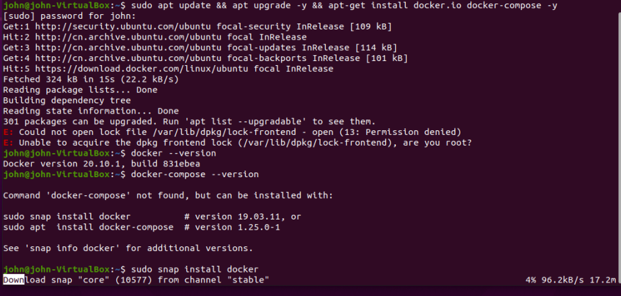

To check the version of your Docker Engine, and Compose, use the following commands:
$ docker --version
$ docker-compose --version
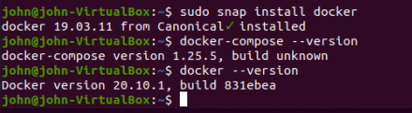
If you got the following info, it means you have to install docker-compose
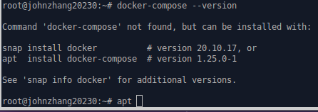
To install it, type the following command:
$ sudo apt install docker-compose
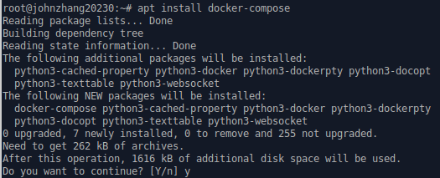
Step 2: clone the docker-hbase project
We will use ready-made Docker-Hadoop-HBase composition from github. First, you need to download/clone the project from the gitbub.
Type the following command to clone the docker-hbase project

$ git clone https://github.com/big-data-europe/docker-hbase

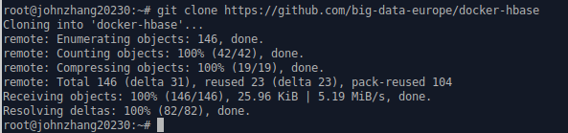

Suppose the docker-hbase is cloned/downloaded to your home directory, cd to the directory:

$ cd docker-hbase

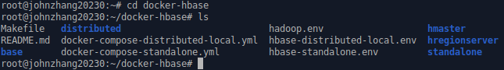
To deploy an example standalone HBase cluster, run:

$ docker-compose -f docker-compose-standalone.yml up -d

It will take a while. Please be patient.

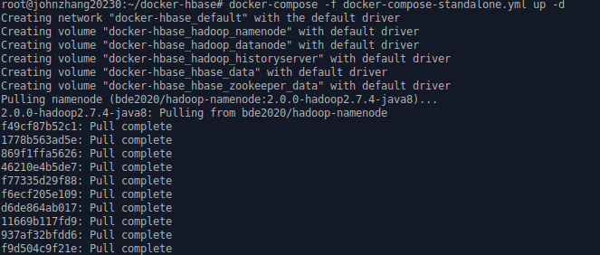

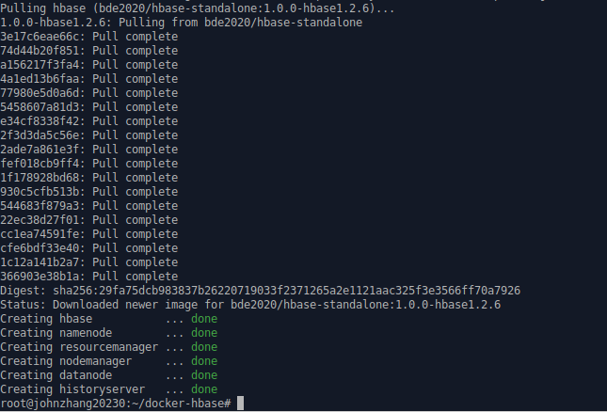

Step 3: Running the Hadoop HBase Cluster

Type command to find out container ids
$ docker ps
You will find 6 containers related to hbase cluster.
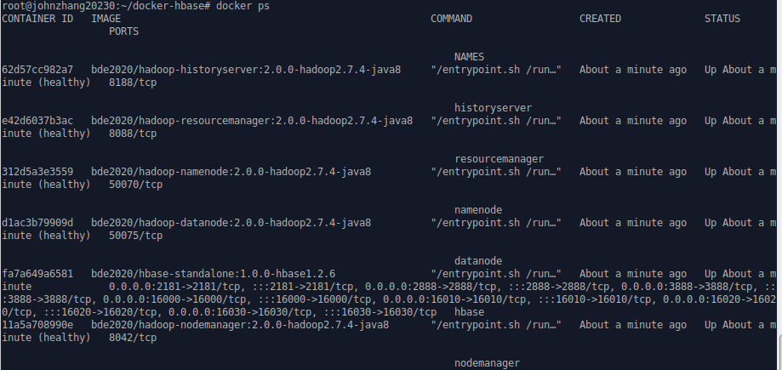
Now we can run the Hadoop HBase cluster.
Enter the following command to run hbase cluster:
$ docker exec -it hbase bash

Step 4: Use HBase
- Connect to HBase.
Connect to your running instance of HBase using the hbase shell command, located in the bin/ directory of your HBase installation. In this example, some usage and version information that is printed when you start HBase Shell has been omitted. The HBase Shell prompt ends with a > character.
$ hbase shell
hbase(main):001:0>
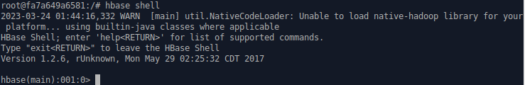
- Display HBase Shell Help Text.
Type help and press Enter, to display some basic usage information for HBase Shell, as well as several example commands. Notice that table names, rows, columns all must be enclosed in quote characters.
hbase(main):001:0>help
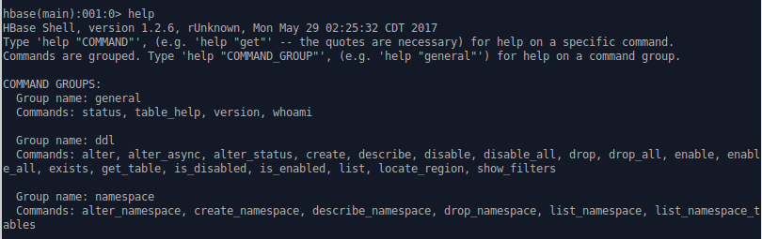
- Create a table.
Use the create command to create a new table. You must specify the table name and the ColumnFamily name.
hbase(main):002:0> create 'test', 'cf'

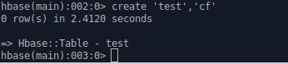
- List Information About your Table
Use the list command to confirm your table exists
hbase(main):003:0> list 'test'

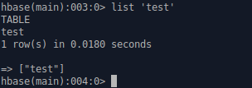

Now use the describe command to see details, including configuration defaults
hbase(main):004:0> describe 'test'
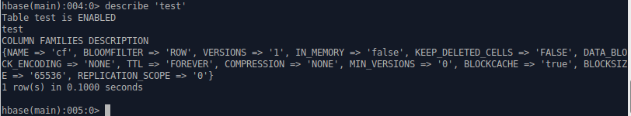

- Put data into your table.
To insert data into your table, use the put command.
hbase(main):005:0> put 'test', 'row1', 'cf:a', 'value1'

hbase(main):006:0> put 'test', 'row2', 'cf:b', 'value2'

hbase(main):007:0> put 'test', 'row3', 'cf:c', 'value3'

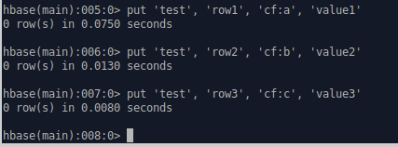

Here, we insert three values, one at a time. The first insert is at row1, column cf:a, with a value of value1. Columns in HBase are comprised of a column family prefix, cf in this example, followed by a colon and then a column qualifier suffix, a in this case.
- Scan the table for all data at once.
One of the ways to get data from HBase is to scan. Use the scan command to scan the table for data. You can limit your scan, but for now, all data is fetched.
hbase(main):009:0> scan 'test'

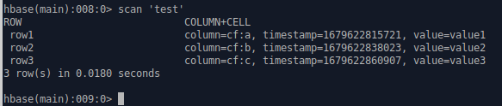
- Get a single row of data.
To retrieve a single row of data at a time, use the get command.
hbase(main):009:0> get 'test', 'row1'

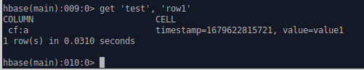

- Disable a table.
If you want to delete a table or change its settings, as well as in some other situations, you need to disable the table first, using the disable command. You can re-enable it using the enable command.
hbase(main):010:0> disable 'test'

hbase(main):011:0> enable 'test'

Disable the table again if you tested the enable command above:
hbase(main):012:0> disable 'test'

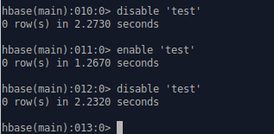
- Drop the table.
To drop (delete) a table, use the drop command.
hbase(main):013:0> drop 'test'

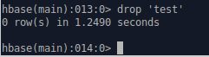

- Exit the HBase Shell.
To exit the HBase Shell and disconnect from your cluster, use the quit command. HBase is still running in the background.
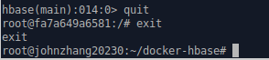

Step 5： Run Hbase container again
You need to start the HBase container again.
$ docker exec -it hbase bash
This time, you need to create a hbase table to save the following data. You can name this table as Mytable, for example.
 | Home |  | Office |  | Social
RowKey | First | Last | Phone | Email | Phone | Email
101 | Florian | Krepsbach | 555-1212 | florian@wobegon.org | 666-1212 | fk@phc.com
102 | Marilyn | Tollerud | 555-1213 |  | 666-1213
103 | Pastor | Inqvist |  |  | 555-1214 | inqvist@wels.org

This table has three column families and three row keys.
Use the commands you have learned in Step 4 to insert the data into the table and get the data from the table.
Basically, you are asked to repeat the major steps in Step4, but work on this new table.
$ docker exec –it hbase hash

# hbase shell

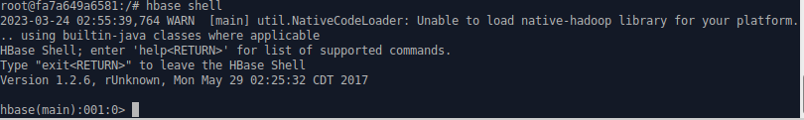
Hbase(main):001:0> create 'Mytable', 'Home', 'Office', 'Social'

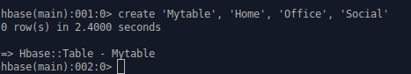
Hbase(main):002:0> list 'Mytable'


